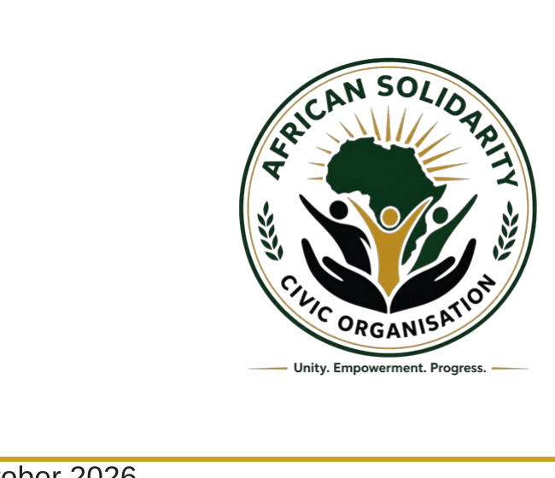 | AFRICAN SOLIDARITY CIVIC ORGANISATION  (ASCO)  Registered NPC: 2026/521895/08 | Tax Reference: 9322812265  49 Rif Road, Manor Gardens  Durban, KwaZulu-Natal  4001  info@africansolidaritycivic.org | www.africansolidaritycivic.org
13 October 2026
Mr. M. Amoodge
Management
Ikhwezi Bus Services
Richards Bay, KwaZulu-Natal
Notification of Postponement – ASCO 15th Event
Dear Mr. Amoodge,
On behalf of the African Solidarity Civic Organisation (ASCO), we wish to inform Ikhwezi Bus Services that our planned 15th event has been postponed.
Due to ongoing strikes and unrest in Durban, the Municipality has advised ASCO to place the event on hold for the time being. In the interests of the safety and wellbeing of participants, partners and supporters, we have therefore decided to postpone the event until it is appropriate to proceed.
We apologise for any inconvenience this may cause and appreciate your understanding. ASCO remains committed to the event and will communicate the confirmed date once the Municipality has advised that it is safe and suitable to continue.
We sincerely hope that Ikhwezi Bus Services will still be willing to support ASCO with the required transport arrangements once the new date has been confirmed. Your continued interest and partnership would be greatly appreciated.
Thank you for considering our request and for your understanding during this period. We will keep you updated regarding the revised arrangements.
Yours faithfully,
Ms Mbali Felicia Dumisa
African Solidarity Civic Organisation (ASCO)
Contact: +27 76 757 5773 | Email: info@africansolidaritycivic.org
SARS PBO Reference: 930092287

